**Activity 2: Creating an Ntier Architecture using CF Template contd**

* Now lets try to add subnets as shown below  
  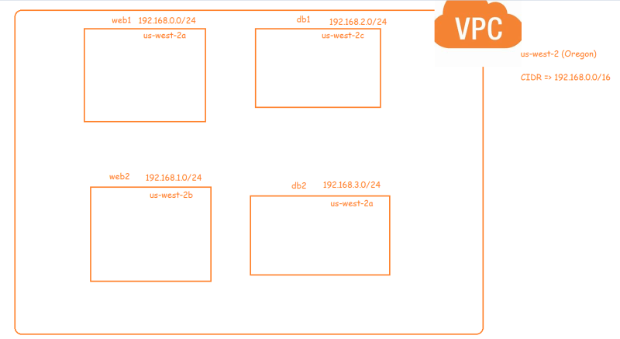
* The manual way of creating subnet is as shown below  
  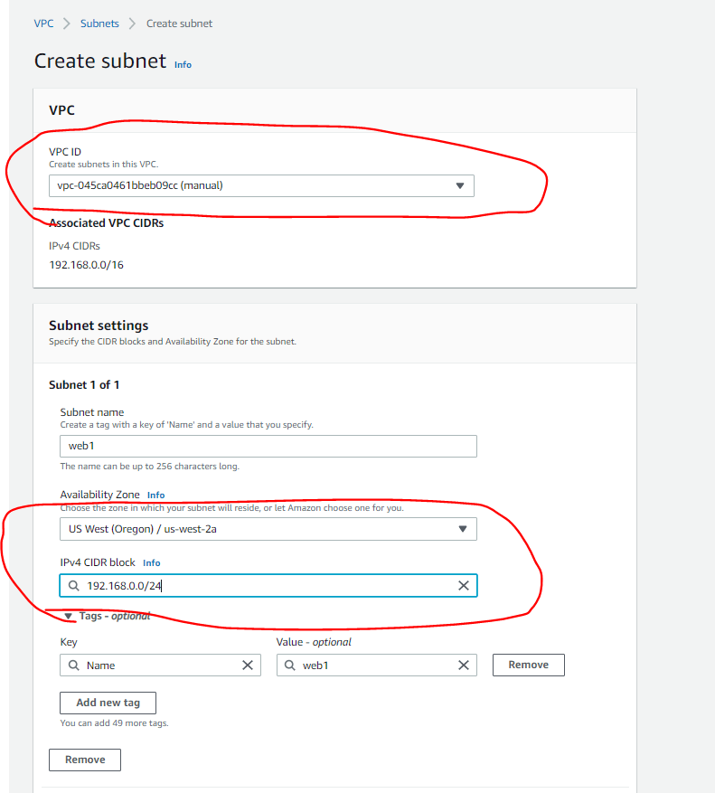
* <https://docs.aws.amazon.com/AWSCloudFormation/latest/UserGuide/aws-resource-ec2-subnet.html> for the resource documentation of cloud formation subnet
* Sometimes when we create resources, we might need info about other resources created with in the template. IN this case we need vpc id
* AWS Cloudformation has return values, which can be used by other resources to fetch the information about the created resource.
* To get the vpc id we just need to use the ref function  
  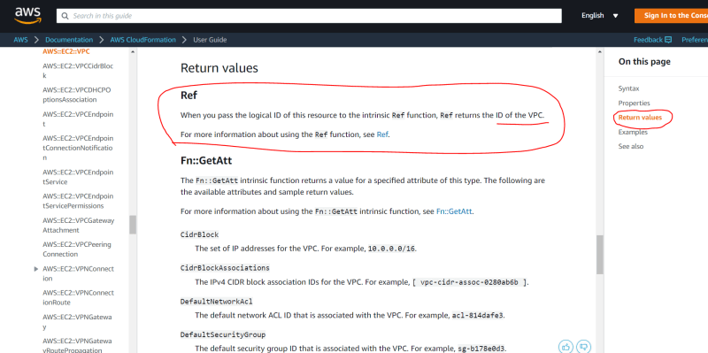
* <https://github.com/asquarezone/awsadministration/commit/a1e37b618fd8d9db793c51d7c1133ce0695053f6> for the changes done and the create the stack
* The resources created are  
  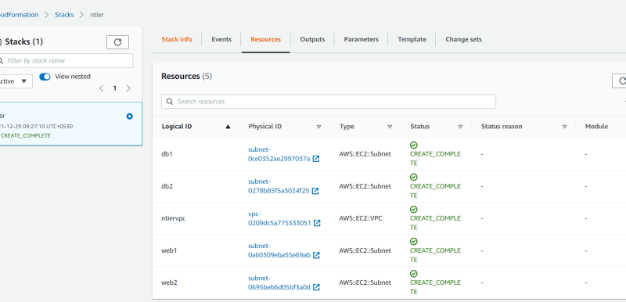  
  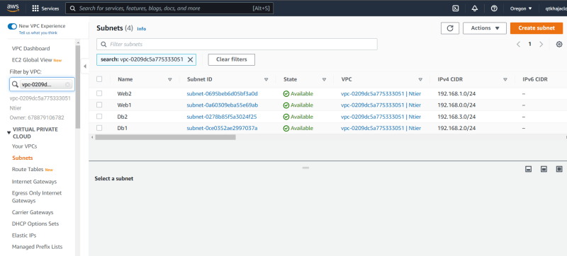
* Create a parameter for cidr ranges and to select the indiviudal item used Fn::select <https://docs.aws.amazon.com/AWSCloudFormation/latest/UserGuide/intrinsic-function-reference-select.html>
* <https://github.com/asquarezone/awsadministration/commit/e01f6cb5ee171c45c01ec49a43ac7d857b80a147> for the changes done
* As of now our template has hard coded AZ values, if we parametrize them the template can be executed in any region
* AWS has some AWS-specific parameter which we can use so that it would be useful <https://docs.aws.amazon.com/AWSCloudFormation/latest/UserGuide/parameters-section-structure.html#aws-specific-parameter-types>
* <https://github.com/asquarezone/awsadministration/commit/3306cda6ce0d2ea6f352c163625a9b1c09cf2471> for the changes made to the template
* Now try to use the template then update the stack so in properties we would see the following  
  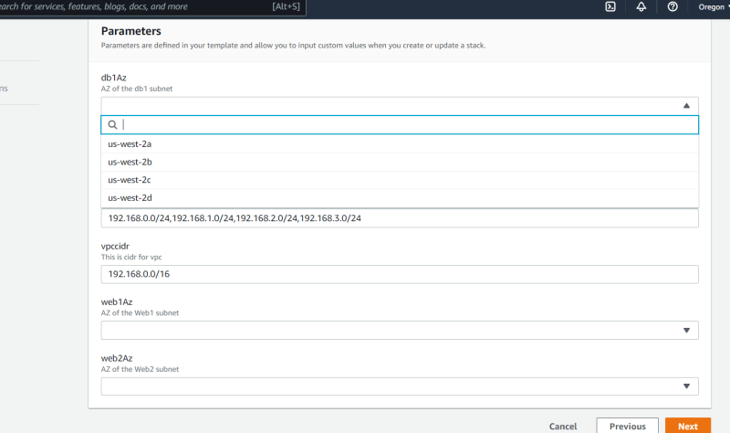
* Now lets try to create and attach internet gateway to our vpc  
  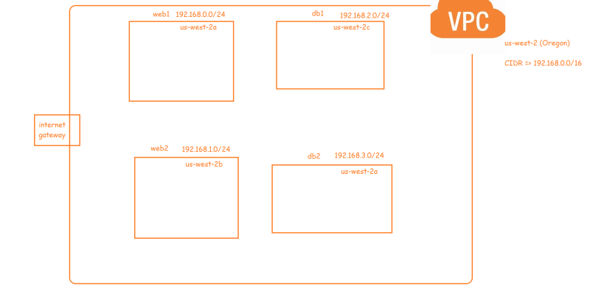
* <https://github.com/asquarezone/awsadministration/commit/4766b6d5f8f94f9b3b1e90e5853d73f53352e476> for the changes done
* Apply the template to create the stack  
  